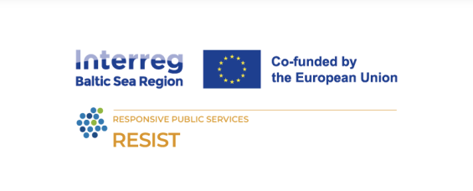**Title: Finance and Resources**

**Learning Objectives:** This module will focus on two parts - access to finance (classical and alternative) and resource management of your own or planned enterprise.

* **Learn how maturity affects** financing needs and **Practice** how toapply the most useful **finance evaluation methods** and **tools** to assess different aspects of financial capacity.
* **Learn** how to develop a **ccomprehensive resource and finance plan.**
* **Learn** classical and alternative **sources of financing - funds, crowd-funds, angel investors.**

**Learning outcomes:**

Upon completion of this training, you will be ready to:

* **Present** social and ecological goals as important business indicators.
* **Analyze** how maturity affects the performance of your organization’s financial capacity.
* **Select and apply** the most effective and applicable tools and methods for finance building.
* Understand how the financing of social enterprises works.
* Identify **key finance issues** of an enterprise.
* Understand the role of **incubators** and **accelerators** in supporting social enterprise.

**Lesson plan**

|  |  |  |  |
| --- | --- | --- | --- |
| **Time** | **Content** | **Methodology** | **Materials** |
| 9:00 | Welcoming participants  Introducing the trainer, learning outcomes and agenda  Icebreaker | Share a recent financial news headline and ask participants for their initial reactions.  Use this as a segue to discuss current financial trends or relevant topics in the field. | PC, projector.  Mentimeter (app) or similar |
| 9:15 | Different needs for social enterprise | Presentation 1  How does maturity affect financing needs? | PC, projector. |
| 10:30 | COFFEE BREAK |  |  |
| 11:00 | Importance of mindset to attract the finance | Presentation 2  How to attract investors? | PC, projector. |
| 11:45 | Financing opportunities, typical funding sources: classical and alternative resources  (theoretical part) and **country-specific - tailored** | Presentation 3  What is the right type of funding depending on the company evaluation phase?  Tailored for specific country + EU level | PC, projector |
| 13:00 | LUNCH BREAK |  |  |
| 14:00 | Group work or individual | Practical part: Individual analyses of existing resources available | Framework - sheets or online tool |
| 14:30 | Incubators and other organizations as financial capacity-building entities | Presentation 4 and local examples | PC, projector |
| 15:00 | Key aspects of developing a sustainable finance and resource plan. | Presentation 5 | PC, projector |
| 15:45 | Group work or individual | Practical drafting of sustainable financing plan - sources and risk assessment | Framework - sheets or online tool |
| 16:15 | BEST CASES -  Sharing experience connected to finances - country-specific | Three successful cases of financing social enterprises, tailored to a specific region, purpose | A guest speaker (to be tailored according to the target group, region, and interests) |
| 17:00 | Closure & networking | Closure & networking |  |

**The RESIST project is co-financed by the European Union (European Regional Development Fund) under the Interreg Baltic Sea Region Programme**.