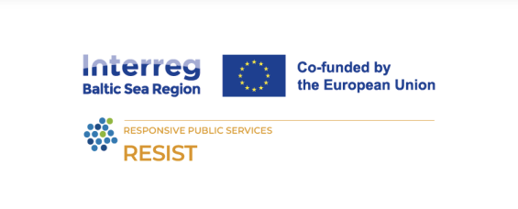**Title: Social business values**

**Learning Objectives:**

* Develop a thorough understanding of **social business values.**
* Deepen knowledgeof **values and competencies** of companies.
* Get to know what **social** **corporate responsibility** is and be able to define it.
* Gain **knowledge of how to align values of social business with corporate values.**
* Learn about **impact steering programme**.
* To get acquainted with **communication ways and tools.**
* Apply learned concepts through **practical exercises.**

**Learning outcomes:**

Upon completion of this training, you will be ready to:

* clearly define and explain the social business values and its’ differences from corporate social responsibility.
* define and explain ways how to align social business values with core competencies of the company.
* select and use tools and methods for communication.
* understand and use the impact steering programme.

**Lesson plan**

|  |  |  |  |
| --- | --- | --- | --- |
| **Time** | **Content** | **Methodology** | **Materials** |
| 9.00 | Welcoming participants  Introducing the trainer, learning outcomes and agenda | Presentation | PC, projector. |
| 9.10 | Difference of social business and corporate social responsibility | **Presentation 1 & discussion.**  **Slides 1-32**  Social business definition  Corporate social responsibility: definition  Differences  Similarities | PC, projector. |
| 10.00 | Share in pairs/groups | **Exercise**: to be selected by trainer | Flipchart |
| 10.30 | Aligning social values with company’s core competencies | **Presentation 2 and discussion**  **Slides 1 – 31**  Benefits;  Strategies  Case studies. | PC, projector |
| 11.30 | Coffee break |  |  |
| 11.50 | Internal and external communication | **Presentation 3**  **Slides 1 – 24**  The power of communication  External and internal communication  Roadmap to effective communication  Communicate your impact. | PC, projector |
| 12.50 | ​ | **Discussion** |  |
| 13.00 | Lunch |  |  |
| 14.00 | Impact steering | **Presentation 4**  **Slides 1 – 22**  Impact Steering programme  Ambitions and activities  Impacts and stakeholders | PC, projector |
| 14.45 |  | **Presentation 4**  **Slides 23 – 31**  Steering and assessment  Reporting and reviews | PC, projector |
| 15.15 | Group work | **Exercise:** To be selected by the trainer | Flipchart |
| 16.30 |  | **Discussion**: Main findings |  |
| 17.00 | End of program |  |  |

**The RESIST project is co-financed by the European Union (European Regional Development Fund) under the Interreg Baltic Sea Region Programme**.