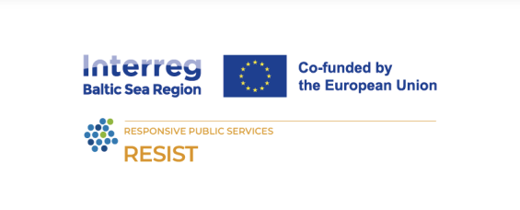

**Title: Social business as organizational value**

**Learning Objectives:**

* Develop a thorough understanding of **social values strategies alignment.**
* Learn to **identify the roles of leadership.**
* To be able to identify common challenges.
* Apply **solutions for integration** of social responsibility to the company.

**Learning outcomes:**

* Understand and implement strategies for **aligning social values** with business operations.
* Recognize the **roles and influence of leadership** in fostering a culture of social responsibility.
* Identify and address common **challenges** in integrating social values into business practices.
* **Develop and implement solutions** that enhance the integration of social responsibility into the organizational fabric.

**Lesson plan**

|  |  |  |  |
| --- | --- | --- | --- |
| **Time** | **Content** | **Methodology** | **Materials** |
| 9.00 | Welcoming participants  Introducing the trainer, learning outcomes and agenda | Icebreaker exercise: to be selected by the trainer | PC, projector. |
| 9.15 | Social business as organizational value | **Presentation 1**  **Slides 1-21**  Organizational culture  Organizational values  Aligning social values with organizational | PC, projector. |
| 10.00 | Share in pairs/groups | **Exercise**: to be selected by the trainer | Flipchart |
| 10.30 | Leadership and employee engagement | **Presentation 2**  **Slides 1 – 19**  Leader’s role  Employee’s role  Working together | PC, projector |
| 11.00 | Break |  |  |
| 11.20 | Challenges and solutions | **Presentation 3**  **Slides: 1 – 22**  Challenges and barriers for social business  Solutions for organizations | PC, projector |
| 12.00 | Group work. | **Exercise**: to be selected by the trainer | Flipchart |
| 13.00 | Lunch |  |  |
| 14.00 | Discussion on group work results | **Discussion**: main findings | Flipchart |
| 15.00 | Closure & networking |  |  |

**The RESIST project is co-financed by the European Union (European Regional Development Fund) under the Interreg Baltic Sea Region Programme**.