**Introduction to the "Train the Trainers" Module: Flexibility through the 'Mix and Match' Approach**

**Introduction**

The "Train the Trainers" module is a comprehensive, customizable framework designed to empower trainers in the Baltic Sea region to effectively support social economy entities. The core of this innovative training program lies in its "Mix and Match" approach, which offers unprecedented flexibility, allowing organizations to tailor their training sessions by selecting specific presentations from various modules. This method not only accommodates diverse learning and organizational needs but also enhances the applicability of training in real-world scenarios.

**Length of the module**

The suggested length of each module in the "Train the Trainers" program is 1 full day, which is why each module consists of around 5 presentations. This structure provides a thorough exploration of the topic while allowing trainers to add their own input and modify the content to meet the specific needs of their audience. This structure ensures comprehensive coverage and allows participants to fully engage with the content both on theoretical and practical assignments and get the sense of localisation and customisation.

### **Target Audience and its Selection**

**Social Economy Entities:**

**Leaders and Decision-Makers:** This includes founders, executives, and senior managers of social enterprises, non-profits, and cooperatives who are pivotal in strategy formulation and implementation.

**Program Managers and Facilitators:** Those responsible for developing and overseeing social programs that require an understanding of capacity building, funding strategies, and sustainable business models.

**Conventional Economy Entities:**

**Corporate CSR Executives**: Leaders and managers responsible for corporate social responsibility initiatives, seeking to deepen their engagement with social impacts and integrate these practices into their business strategies.

**Business Developers**: Professionals focused on developing new business models that incorporate social values into traditional business operations, aiming to create sustainable and socially responsible growth.

**Human Resources Professionals**: Individuals looking to cultivate a socially aware and engaged workforce, ensuring that CSR principles are embedded in the company culture and employee practices.

**Flexibility and Customization**

The "Mix and Match" approach allows piloting organizations to choose entire modules or individual parts, creating a customized training program that best fits their and their stakeholders’ needs. This flexibility is essential in addressing the unique challenges and opportunities within the Baltic Sea region's social economy.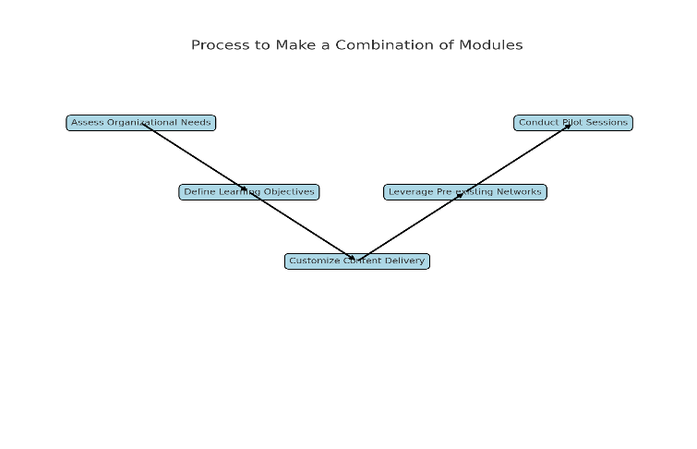

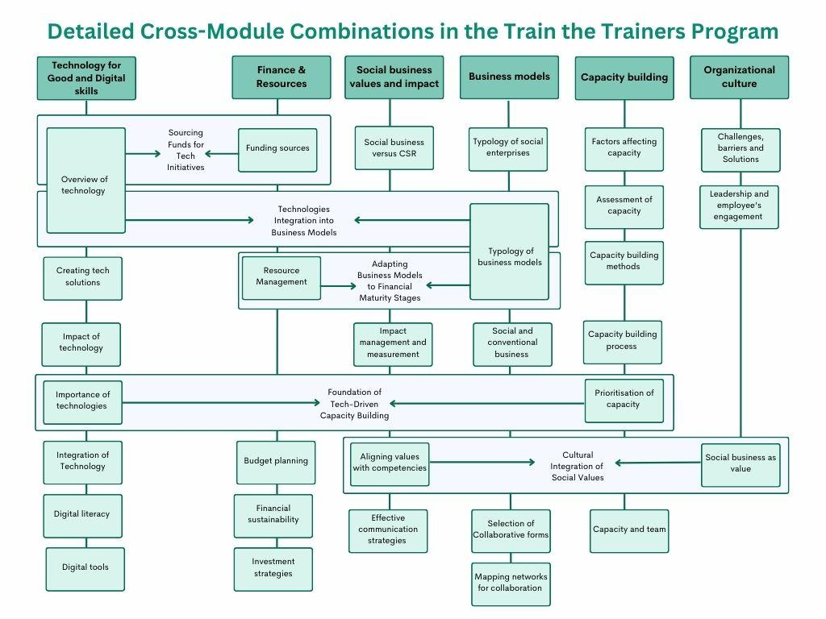

1. **Modular Structure: Flexibility of Content**:

The training is structured in distinct but interconnected modules that cover various aspects of social and conventional business practices. Organizations can choose individual modules that address their immediate needs or combine several modules to provide comprehensive training.

Example: An organization focusing on improving their CSR activities might select modules related to 'Values and Impact' and 'Finance & Resources', whereas one looking to enhance operational capacity might choose 'Capacity Building' and 'Business Models'.

**2.** **Tailored Learning Paths**:

**Role-Specific Customization**: Training can be customized to the roles of the participants within the organization. For example, training for senior management can focus more on strategic decision-making and policy development, while training for mid-level managers can focus on operationalizing strategies and leading teams effectively.

**Sector-Specific Adaptations**: Depending on whether the organization is more socially or commercially oriented, the content can be tailored to emphasize either social impact or commercial viability, with relevant case studies and examples.

**Integration of Social and Conventional Economies through Shared Learning**

The "Train the Trainers" module not only serves the specific needs of social economy entities but also offers valuable insights and strategies applicable to conventional businesses. This dual applicability underscores a pivotal goal of the program: fostering integration between the social and conventional economies by promoting a shared understanding and application of sustainable and socially responsible business practices.

**Shared Learning Benefits**

1. **Cross-Sector Learning and Application**

For Social Enterprises: Social economy entities can leverage business models and strategies typically associated with conventional businesses to enhance their operational efficiency and market competitiveness.

For Conventional Businesses: Conventional enterprises can adopt social impact strategies from the training modules to improve their corporate social responsibility (CSR) initiatives and integrate deeper social values into their core operations.

Example 1: Business Models and Resource Management

Interlinked Learning: By participating in sessions such as "Different Forms of Business Models" and "Finance & Resources", both social and conventional enterprises can learn how to optimize their business structures and financial strategies to support sustainable growth and social impact.

**Outcome**: Conventional businesses can discover new ways to incorporate social objectives into their operations, while social businesses can enhance their commercial viability and scalability.

2. **Encouraging Collaborative Approaches**

Joint Ventures: Modules like "How to Choose the Most Useful and Beneficial Form of Collaboration" encourage entities from both sectors to explore partnerships that leverage each other's strengths, promoting collaborative projects that benefit wider communities.

Example 2: Collaborative Projects and Partnerships

Structured Pathway: Engaging both types of entities in discussions about forming partnerships can lead to innovative project collaborations that address community needs while also providing business value.

**Outcome**: These partnerships can lead to projects that not only drive social change but also open new markets and opportunities for conventional businesses, promoting a more integrated economic approach.

3. **Fostering Mutual Cultural Adaptations**

Cultural Exchange: The module "Social Business as Organizational Value" offers strategies for embedding social values within corporate cultures. This cross-pollination of values can help conventional businesses to more authentically engage in CSR activities while allowing social businesses to adopt robust business practices.

Example 3: Integrating Values and Impact

Implementation Strategy: Businesses from the conventional sector can learn how to authentically integrate social values, thereby enhancing their brand loyalty and consumer trust. Conversely, social enterprises can learn from conventional businesses how to implement efficient operational strategies without compromising their social missions.

**Outcome**: This mutual cultural adaptation enhances both the authenticity and efficiency of enterprises across sectors, leading to a more cohesive business ecosystem that values both profitability and social impact.

**Conclusion of Shared Learning Benefits**

By engaging both social and conventional economy entities in the "Train the Trainers" modules, the program not only enhances the capabilities of each but also facilitates a more integrated approach to economic development. This integration helps in breaking down the barriers between social and conventional business practices, leading to a more inclusive and sustainable economic landscape in the Baltic Sea region.

**Examples of Interlinked Modules**

Example 1: **Combining 'Tech for Good' with 'Finance & Resources'**

Starting Point: Begin with the "Overview of Technologies" from the "Tech for Good" module to introduce the latest innovations.

Deep Dive: Move to "Funding Sources" from the "Finance & Resources" module to explore how these technologies can be financed.

Application: Use "Creating a New Technological Solution" from "Tech for Good" to apply learned financial strategies in technology project planning.

This pathway helps organizations understand not only the potential of technology in social enterprises but also the practical aspects of funding and implementing technological solutions.

Example 2**: Integrating 'Values and Impact' with 'Business Models'**

Foundation: Start with "Social Business vs. Corporate Social Responsibility" from the "Values and Impact" module to set the ethical foundation.

Structural Planning: Continue with "Different Forms of Business Models" from the "Business Models" module to identify which models align with these values.

Implementation: Use "Impact Steering" from "Values and Impact" to measure and manage the impact based on the chosen business model.

This combination allows trainers to guide organizations through the process of aligning their social missions with viable business models and operationalizing these models to maximize social impact.

Example 3: **Linking 'Capacity Building' with 'Social Business as Organizational Value'**

Initial Training: Start with "Introduction to Capacity Building" from the "Capacity Building" module to build foundational knowledge.

Cultural Integration: Follow with "Social Business as Organizational Value" to integrate these capacities into the organization's cultural fabric.

Ongoing Development: Conclude with "Continuous Capacity Building" to ensure the organization maintains and enhances these capabilities over time.

This sequence ensures that organizations not only build initial capacity but also integrate and sustain these improvements as part of their organizational culture, enhancing long-term social impact.

**Target Audience and its selection**

**Social Economy Entities:**

**Leaders and Decision-Makers:** This includes founders, executives, and senior managers of social enterprises, non-profits, and cooperatives who are pivotal in strategy formulation and implementation.

**Program Managers and Facilitators:** Those responsible for developing and overseeing social programs that require an understanding of capacity building, funding strategies, and sustainable business models.

**(Local/regional) Policy Makers and Advocates:** Individuals in roles that influence policy and advocacy within the social sector, needing skills to effectively train and disseminate best practices.

**2. Conventional Economy Entities:**

**Corporate CSR Executives:** Leaders and managers responsible for corporate social responsibility initiatives looking to deepen their engagement with social impacts.

**Business Developers:** Professionals focused on developing new business models that integrate social values into traditional business operations.

**Human Resources Professionals:** Those looking to cultivate a workforce that is socially aware and engaged in corporate social responsibility.

**Strategies for Selecting Specific Training Groups**

**Effective Participant Selection Process:**

**1. Assess Organizational Needs:**

Conduct detailed assessments to determine the specific learning needs of potential participant organizations. Utilize tools such as surveys, interviews, and focus groups to gather comprehensive data on their current capabilities and gaps in knowledge.

**2. Define Learning Objectives:**

Clearly articulate the learning objectives of the training module. Ensure these objectives align with the strategic goals of the potential participant organizations. This alignment ensures that the training delivered is relevant and can be effectively applied to meet organizational goals.

**3. Customize Content Delivery:**

Tailor the training content and delivery methods to match the unique characteristics of the audience. For example, more interactive and practical training methods may be suitable for operational staff, whereas strategic and policy-oriented content may be better suited for senior leaders and decision-makers.

**4. Leverage Pre-existing Networks:**

Utilize networks within social and conventional economy spheres to identify and engage potential participants. Networks such as industry associations, social enterprise alliances, and business chambers can provide access to organizations that would benefit most from the training.

**5. Pilot (or Feedback) Sessions:**

Conduct pilot training sessions with a small, diverse group of participants to refine the module based on real feedback. This approach allows for the adjustment of content and teaching methods to better suit the needs of a broader audience before full-scale implementation.

**Conclusion**

The "Train the Trainers" module requires a targeted approach to participant selection and content customization. By understanding the diverse backgrounds and needs of participants from both social and conventional economy entities, trainers can deliver more impactful, practical, and sustainable outcomes. This strategic approach not only enhances the effectiveness of the training but also fosters greater integration and collaboration between the social and conventional economies, leading to a more inclusive economic landscape.

The "Train the Trainers" program, with its "Mix and Match" approach, provides a versatile and effective training solution for the diverse needs of the social economy in the Baltic Sea region. By allowing organizations to customize their learning paths, this approach ensures that training is not only relevant and targeted but also supports the strategic development of social economy entities and their support organizations.

**The RESIST project is co-financed by the European Union (European Regional Development Fund) under the Interreg Baltic Sea Region Programme**.