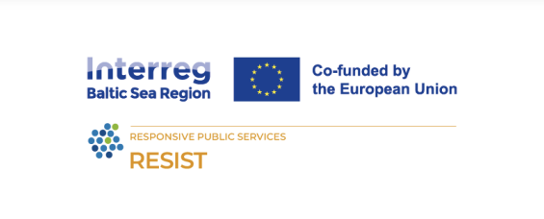
Module 6 – Social Innovation: from identification to empowerment
Title: How to Identify, Strengthen and Scale Social Innovation in Communities

Learning Objectives
• Understand key concepts and definitions of social innovation.
• Identify, evaluate, and document local and rural social innovations.
• Recognize barriers and enablers for scaling and sustainability.
• Learn methods for mapping, storytelling, and participatory research.
• Apply power-building principles to shift decision-making toward communities.
• Integrate social innovation approaches into their own programs or organizations.

Learning Outcomes
• Recognize genuine social innovation versus short-term aid projects.
• Use participatory methods (PRA, Community Innovation Mapping, Storytelling) to identify social innovations.
• Understand ethical and governance aspects of community power-building.
• Design co-creation and collaboration models for scaling innovations.
• Be ready to facilitate social innovation training sessions in their own regions.

Lesson Plan
Time | Content / Topic | Methodology | Materials
9:00 – 9:15 | Welcome & Introduction | Trainer introduction, objectives, and expectations | Presentation 1 Slides 1–5, PC + Projector
9:15 – 10:30 | Understanding Social Innovation – Definition, characteristics, difference from traditional initiatives | Interactive presentation + open discussion | SOCIAL-INNOVATION_1st_part (4).pptx
10:30 – 11:00 | Identifying Local and Rural Innovations – Community-based examples | Group brainstorming & mapping exercise | Localized-SOCIAL-INNOVATION_1st_part (1).pptx
11:15 – 12:30 | Methods & Tools to Map Innovation – Community Innovation Mapping, PRA, Storytelling & Oral Histories | Case-based exercise, small group practice | Flipchart, Markers, PC + Projector
13:30 – 14:30 | Power-Building in Social Innovation – Governance, leadership pipelines, ownership models | Presentation + discussion | Power of Community – Social Innovation.pptx
14:30 – 15:15 | Mechanisms that Redistribute Power – Participatory budgeting, co-ops, citizen assemblies | Diagram analysis + interactive Q&A | Printed Slide 16 visual
15:30 – 16:30 | Scaling and Measuring Impact – Growth without losing identity + evaluation metrics | Group exercise: design a scaling plan | Localized & Power of Community presentations
16:30 – 17:00 | Reflection & Next Steps – Commitment to action and network sharing | Facilitated discussion + feedback | Flipchart + evaluation form

Suggested Practical Activities
• Innovation Mapping Lab: Participants identify and map three local social innovations using PRA and storytelling methods.
• Power Shift Simulation: Groups simulate community-decision meetings using participatory budgeting frameworks.
• Case Study Analysis: Examine Baltic Sea Region examples (SEMPRE, BSI_4Women, Cultural Pearls) and discuss success factors.

Assessment & Follow-Up
• Group presentation of identified social innovations.
• Reflection journals on lessons learned.
• Trainer feedback and peer evaluation.
The RESIST project is co-financed by the European Union (European Regional Development Fund) under the Interreg Baltic Sea Region Programme.

